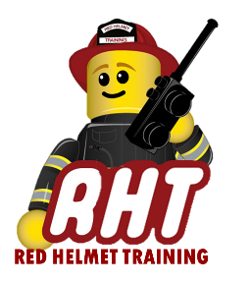
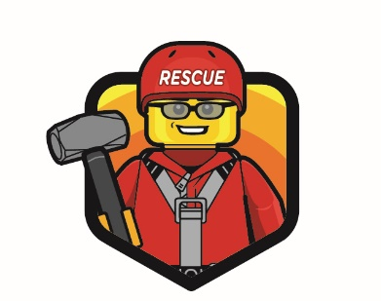
Rescue Helmet Training
Technical Rescue Classes

Announces: Low Angle Rope Rescue

Dates: June 20, 21, and 22, 2022

Times: 8:00 a.m. – 5:00 p.m.

Location: Alhambra Fire Training Center
911 S. New Avenue
Alhambra, CA 91801

Instructor: Guy Brown & Staff

Fees / Materials: $500.00 – Payable to Red Helmet Training
Covers cost of SFT Certificate & Materials

Class Description: Designed to equip the student with the techniques and methods for using rope, webbing, hardware friction devices, litters in low angle rescue situations. Areas covered include rope and related equipment, anchor systems, safety lines, stretcher lashing and rigging, mechanical advantage systems, and single-line and two-line rescue systems.

PPE Required: Structure or US&R Helmet, Station or US&R Boots, Station or US&R uniform, Brush Lightweights or US&R Long Sleeve Jacket

Prerequisites: None

To register for this course please visit the web site.

www.RedHelmetTraining.com

