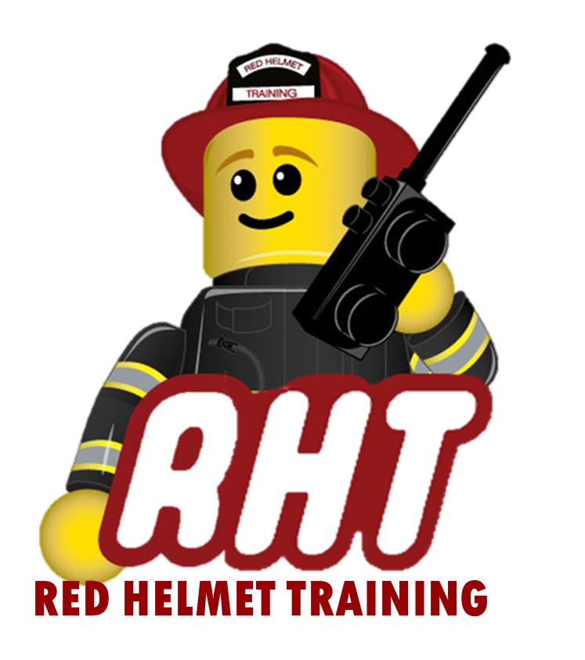
Red Helmet Training
Wildland Fire / ICS Courses

Announce: S-203 Introduction to Incident Information

Dates: June 12, 13, 14, and 15, 2023

Times: 8:00 a.m. – 5:00 p.m.

Location: Red Helmet Training Classrooms
10601 Church Street #107
Rancho Cucamonga, CA 91730

Fees / Materials: $400.00 – Payable to Red Helmet Training

Class Description: The Introduction to Incident Information is designed to provide you with the knowledge and skills you will need to serve as a Type F information officer on wildland fires and other incidents. During the course, we will touch on virtually all aspects of establishing and maintaining an incident information operation, from getting organized to communicating with internal and external audiences, to handling special situations. Social Media and new PIO practices will be emphasized.

Instructors: Doug Lannon – BDU Assistant Chief (Ret.) RHT Staff
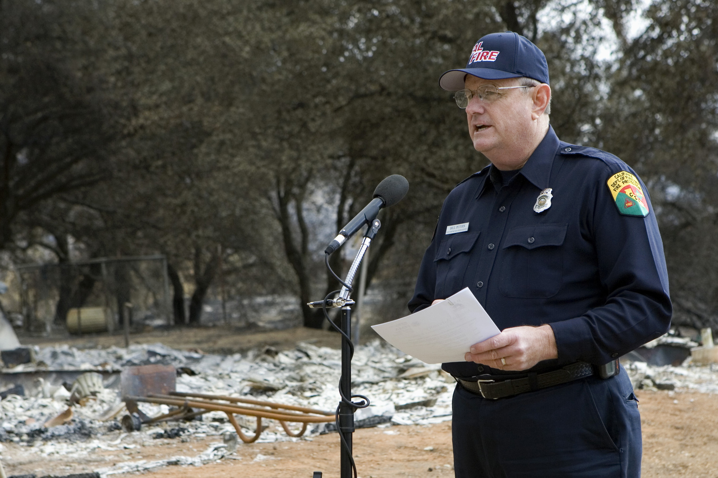
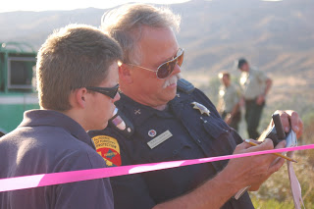

Red Helmet Training

Playing to Learn, Learning to Play


Red Helmet Training

Playing to Learn, Learning to Play
www.RedHelmetTraining.com

Course Registration Form

Student Name: Course:

Course Dates: Course Location:

Home Address: City: Zip:

Home Phone: Cell:

E-Mail Address:

Organization: Title:

To be added to the e-mail list for upcoming classes please visit the Red Helmet Training website.

Reservations are required for all classes unless specified. No phone reservations will be accepted.
You must send in a check or pay electronically to reserve your seat. If your department is paying for you to attend then we will shred your personal check or refund your electronic payment upon receipt of your department check. Checks are not processed until the last day of class so please plan accordingly. Checks should be dated for the last day of the course. Facility dress code is business casual or department uniform. Shorts or flip flops are not allowed.

You must call at least one week in advance to cancel or your fee will be retained. You will receive a confirmation e-mail once we have processed your reservation form, along with any course instructions. Any course prerequisites or materials required will be listed on the class flyer. These items are your responsibility to bring to class the first day. If you do not have them you will be dropped from class.

Reservations are on a first come basis unless spots are held by the sponsoring agency / department.
California State Fire Marshal CFSTES and CSTI certificates may take 6 to 8 weeks to process.

If you have any questions, please contact the primary instructor for the course.

Please complete this form and submit with your payment made payable to Red Helmet Training.

Mail all registration forms with payments to:

Red Helmet Training
10601 Church Street #107
Rancho Cucamonga, CA 91730

