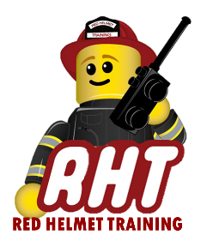
Rescue Helmet Training
Technical Rescue Classes

Announces: Trench Rescue Technician

Dates: March 27, 28, and 29

Times: 8:00 a.m. – 5:00 p.m.

Location: Alhambra Fire Training Center
911 S. New Avenue
Alhambra, CA 91801

Instructor: Mike Wolfe, Kyle Johnson
(Task Book Students are encouraged to attend)

Fees / Materials: $750.00 – Payable to Red Helmet Training
Covers cost of SFT Certificate & Materials

Class Description: Covers NFPA 1006 Chapter 12 (Trench Rescue) Operations and Technician Level Skills.
Trench Rescue Technician is an intensive 24-hour Trench Rescue class that provides hands-on training and real-life scenarios allowing the student to gain confidence in this dangerous environment. 24 students maximum

PPE Required: Structure or US&R Helmet, Station or US&R Boots, Station or US&R uniform, Brush Lightweights or US&R Long Sleeve Jacket, Gloves

Prerequisites: None

To register for this course please visit the web site.
www.RedHelmetTraining.com

