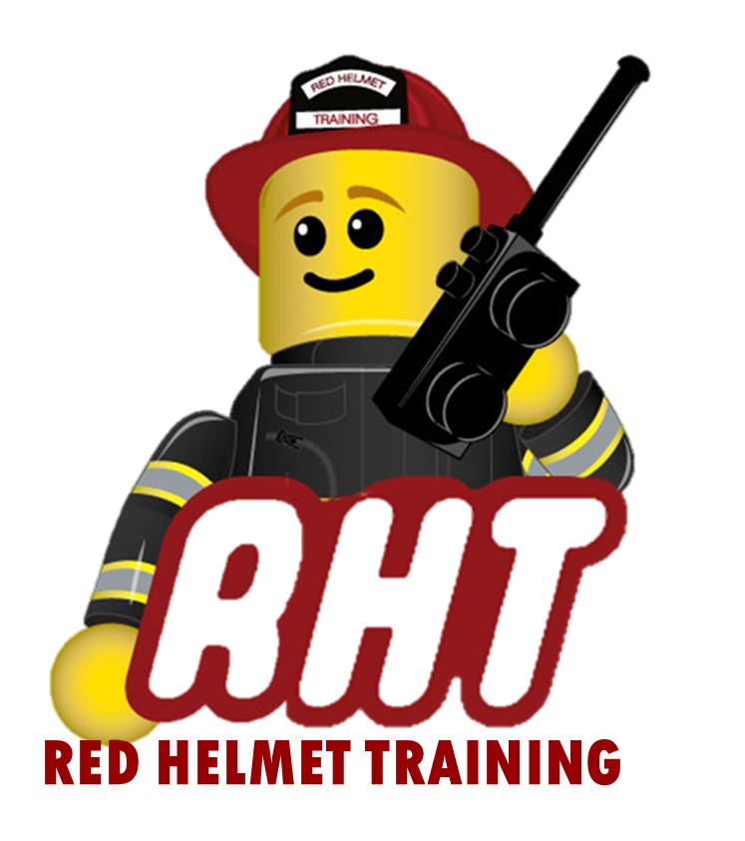
Red Helmet Training
Fire Officer Courses

Course: ICS-300 - Intermediate ICS

Dates: November 10, 11, and 12, 2025

Times: 8:00 a.m. – 5:00 p.m.

Location: Red Helmet Training Classrooms
8560 Vineyard Avenue, Suite 306
Rancho Cucamonga, CA 91730

Instructor: Battalion Chief (Ret.) Steve Wood

Fees / Materials: $360.00 – Payable to Red Helmet Training.
Covers the cost of the Student Manual and California State Fire Marshal certificate.

Class Description: This course provides description and detail of the Incident Command System organization and operations in supervisory roles on expanding or type 3 incidents. Topics include ICS fundamentals review, incident assessment and agency guidance in establishing incident objectives, unified command, incident resource management, planning process, demobilization, transfer of command and close out. Prerequisite ICS200

To register for this course please visit the web site.


www.RedHelmetTraining.com

Red Helmet Training

Playing to Learn, Learning to Play

Red Helmet Training

Playing to Learn, Learning to Play
www.RedHelmetTraining.com

Course Registration Form
Student Name: SFT ID#:

Course / Location: Dates:

Home Address: City: Zip:

Home Phone: Cell:

E-Mail Address:

Organization: Title:

To be added to the e-mail list for upcoming classes please visit the Red Helmet Training website.

Reservations are required for all classes unless specified. No phone reservations will be accepted.
You must send in a check or pay with PayPal to reserve your seat. If your department is paying for you to attend then we will shred your personal check or deny your PayPal payment upon receipt of your department check. PayPal payments and Checks are not processed until the last day of class so please plan accordingly. Checks should be dated for the last day of the course. Dress code for the facility is business casual or department uniform. No shorts or flip flops will be allowed.

You must call at least one week in advance to cancel or your fee will be retained. You will receive a confirmation e-mail once we have processed your reservation form, along with any course instructions. Any course prerequisites or materials required will be listed on the class flyer. These items are your responsibility to bring to class the first day. If you do not have them you will be dropped from class.

Reservations are on a first come basis unless spots are held by the sponsoring agency / department.

California State Fire Marshal CFSTES and CSTI certificates may take 6 to 8 weeks to process.

If you have any questions, please contact the primary instructor for the course.

Please complete this form and submit with your payment made payable to Red Helmet Training.

Mail all registration forms with payments to:

Red Helmet Training
8560 Vineyard Avenue #301
Rancho Cucamonga, CA 91730

